CODING:
import pandas as pd
# Load dataset
df = pd.read_csv('C:/Users/ASUS/Downloads/ml 1 program .csv')
# Display the first few rows
print("\n First 5 rows of the dataset:")
print(df.head())
# Identify data types
print("\n Data types of each column:")
print(df.dtypes)
# Classify columns by type
numerical_cols = df.select_dtypes(include=['int64', 'float64']).columns.tolist()
categorical_cols = df.select_dtypes(include=['object', 'category']).columns.tolist()
boolean_cols = df.select_dtypes(include=['bool']).columns.tolist()
print("\n Column classification:")
print(f"Numerical columns: {numerical_cols}")
print(f"Categorical columns: {categorical_cols}")
print(f"Boolean columns: {boolean_cols}")
# Summary of missing values
print("\n Missing values per column:")
print(df.isnull().sum())
# Basic statistics for numerical columns
print("\n Descriptive statistics for numerical columns:")
print(df[numerical_cols].describe())
# Value counts for categorical columns
print("\n Value distribution for categorical columns:")
for col in categorical_cols:
print(f"\nColumn: {col}")
print(df[col].value_counts())
# Value counts for boolean columns
print("\n Value distribution for boolean columns:")
for col in boolean_cols:
print(f"\nColumn: {col}")
print(df[col].value_counts())

OUTPUT:

First 5 rows of the dataset:
transaction_id transaction_date ... Day Name boolean
0 114301 6/1/2023 ... Thursday yes
1 115405 6/2/2023 ... Friday yes
2 115478 6/2/2023 ... Friday yes
3 116288 6/2/2023 ... Friday yes
4 116714 6/3/2023 ... Saturday yes
[5 rows x 16 columns]
Data types of each column:
transaction_id int64
transaction_date object
transaction_time object
store_id int64
store_location object
product_id int64
transaction_qty int64
unit_price int64
product_category object
product_type object
product_detail object
Size object
Total_bill int64
Month Name object
Day Name object
boolean object
dtype: object
Column classification:
Numerical columns: ['transaction_id', 'store_id', 'product_id', 'transaction_qty', 'unit_price', 'Total_bill']
Categorical columns: ['transaction_date', 'transaction_time', 'store_location', 'product_category', 'product_type', 'product_detail', 'Size', 'Month Name', 'Day Name', 'boolean']
Boolean columns: []
Missing values per column:
transaction_id 0
transaction_date 0
transaction_time 0
store_id 0
store_location 0
product_id 0
transaction_qty 0
unit_price 0
product_category 0
product_type 0
product_detail 0
Size 0
Total_bill 0
Month Name 0
Day Name 0
boolean 0
dtype: int64

Descriptive statistics for numerical columns:
transaction_id store_id ... unit_price Total_bill
count 9.000000 9.0 ... 9.0 9.0
mean 116358.111111 3.0 ... 3.0 3.0
std 1139.179798 0.0 ... 0.0 0.0
min 114301.000000 3.0 ... 3.0 3.0
25% 115478.000000 3.0 ... 3.0 3.0
50% 116714.000000 3.0 ... 3.0 3.0
75% 116853.000000 3.0 ... 3.0 3.0
max 118056.000000 3.0 ... 3.0 3.0
[8 rows x 6 columns]
Value distribution for categorical columns:
Column: transaction_date
transaction_date
6/3/2023 4
6/2/2023 3
6/1/2023 1
6/4/2023 1
Name: count, dtype: int64
Column: transaction_time
transaction_time
11:33:29 AM 1
11:18:24 AM 1
12:02:45 PM 1
7:39:47 PM 1
12:24:57 PM 1
12:44:17 PM 1
1:58:14 PM 1
6:57:29 PM 1
2:31:43 PM 1
Name: count, dtype: int64
Column: store_location
store_location
Airport 9
Name: count, dtype: int64
Column: product_category
product_category
Tea 9
Name: count, dtype: int64
Column: product_type
product_type
Brewed herbal tea 9
Name: count, dtype: int64
Column: product_detail
product_detail
Peppermint 9
Name: count, dtype: int64
Column: Size
Size
Large 9
Name: count, dtype: int64
Column: Month Name
Month Name
June 9
Name: count, dtype: int64
Column: Day Name
Day Name
Saturday 4
Friday 3
Thursday 1
Sunday 1
Name: count, dtype: int64
Column: boolean
boolean
yes 9
Name: count, dtype: int64
Value distribution for boolean columns:

PRO 2
INPUT:
import pandas as pd
import numpy as np
from scipy import stats
from sklearn.preprocessing import MinMaxScaler, StandardScaler
# Sample dataset with missing values and outliers
data = {
'Feature1': [10, 12, np.nan, 14, 1000, 13, 11, np.nan, 15],
'Feature2': [200, 220, 210, np.nan, 215, 205, 1000, 225, np.nan]
}
df = pd.DataFrame(data)
print("Original Data:\n", df)
# Step 1: Handle Missing Values
def impute_missing(df, strategy='mean'):
for column in df.columns:
if df[column].isnull().sum() > 0:
if strategy == 'mean':
df[column] = df[column].fillna(df[column].mean())
elif strategy == 'median':
df[column] = df[column].fillna(df[column].median())
return df
df_imputed = impute_missing(df.copy(), strategy='mean')
print("\nAfter Mean Imputation:\n", df_imputed)
# Step 2: Detect Outliers using Z-score
def detect_outliers_zscore(df, threshold=3):
outliers = {}
for column in df.select_dtypes(include=[np.number]).columns:
z_scores = np.abs(stats.zscore(df[column]))
outliers[column] = df[column][z_scores > threshold]
return outliers

zscore_outliers = detect_outliers_zscore(df_imputed)
print("\nOutliers Detected using Z-score:\n", zscore_outliers)
# Step 3: Detect Outliers using IQR
def detect_outliers_iqr(df):
outliers = {}
for column in df.select_dtypes(include=[np.number]).columns:
Q1 = df[column].quantile(0.25)
Q3 = df[column].quantile(0.75)
IQR = Q3 - Q1
outliers[column] = df[column][(df[column] < Q1 - 1.5 * IQR) | (df[column] > Q3 + 1.5 * IQR)]
return outliers
iqr_outliers = detect_outliers_iqr(df_imputed)
print("\nOutliers Detected using IQR:\n", iqr_outliers)
# Step 4: Normalize and Standardize
def normalize_standardize(df):
scaler_minmax = MinMaxScaler()
scaler_standard = StandardScaler()

normalized = pd.DataFrame(scaler_minmax.fit_transform(df), columns=df.columns)
standardized = pd.DataFrame(scaler_standard.fit_transform(df), columns=df.columns)
return normalized, standardized
normalized_df, standardized_df = normalize_standardize(df_imputed)
print("\nNormalized Data:\n", normalized_df)
print("\nStandardized Data:\n", standardized_df)Original Data:

OUTPUT:
Feature1 Feature2
0 10.0 200.0
1 12.0 220.0
2 NaN 210.0
3 14.0 NaN
4 1000.0 215.0
5 13.0 205.0
6 11.0 1000.0
7 NaN 225.0
8 15.0 NaN

After Mean Imputation:
Feature1 Feature2
0 10.000000 200.0
1 12.000000 220.0
2 153.571429 210.0
3 14.000000 325.0
4 1000.000000 215.0
5 13.000000 205.0
6 11.000000 1000.0
7 153.571429 225.0
8 15.000000 325.0

Outliers Detected using Z-score:
{'Feature1': Series([], Name: Feature1, dtype: float64), 'Feature2': Series([], Name: Feature2, dtype: float64)}
Outliers Detected using IQR:
{'Feature1': 4 1000.0
Name: Feature1, dtype: float64, 'Feature2': 6 1000.0
Name: Feature2, dtype: float64}

Normalized Data:
Feature1 Feature2
0 0.000000 0.00000
1 0.002020 0.02500
2 0.145022 0.01250
3 0.004040 0.15625
4 1.000000 0.01875
5 0.003030 0.00625
6 0.001010 1.00000
7 0.145022 0.03125
8 0.005051 0.15625

Standardized Data:
Feature1 Feature2
0 -0.471109 -0.514133
1 -0.464546 -0.431872
2 0.000000 -0.473002
3 -0.457983 0.000000
4 2.777431 -0.452437
5 -0.461265 -0.493568
6 -0.467827 2.776318
7 0.000000 -0.411306
8 -0.454702 0.000000

PRO 3
INPUT:
import numpy as np
import pandas as pd
from sklearn.datasets import load_iris
from sklearn.model_selection import train_test_split
from sklearn.tree import DecisionTreeClassifier
from sklearn.neighbors import KNeighborsClassifier
from sklearn.svm import SVC
from sklearn.metrics import accuracy_score, confusion_matrix
# Load dataset (Iris dataset for demonstration)
iris = load_iris()
X = iris.data
y = iris.target
# Split dataset into training and testing sets (80% train, 20% test)
X_train, X_test, y_train, y_test = train_test_split(
X, y, test_size=0.2, random_state=42
)
# Initialize models
models = {
"Decision Tree": DecisionTreeClassifier(random_state=42),
"K-Nearest Neighbors": KNeighborsClassifier(n_neighbors=5),
"Support Vector Machine": SVC(kernel='linear', random_state=42)
}
# Train and evaluate each model
results = {}
for name, model in models.items():
model.fit(X_train, y_train)
y_pred = model.predict(X_test)

acc = accuracy_score(y_test, y_pred)
cm = confusion_matrix(y_test, y_pred)
results[name] = {"Accuracy": acc, "Confusion Matrix": cm}
# 🔹 Add this to actually see the output
for name, metrics in results.items():
print(f"Model: {name}")
print("Accuracy:", metrics["Accuracy"])
print("Confusion Matrix:\n", metrics["Confusion Matrix"])
print("-" * 40)

OUTPUT:
Model: Decision Tree
Accuracy: 1.0
Confusion Matrix:
[[10 0 0]
[ 0 9 0]
[ 0 0 11]]
----------------------------------------
Model: K-Nearest Neighbors
Accuracy: 1.0
Confusion Matrix:
[[10 0 0]
[ 0 9 0]
[ 0 0 11]]
----------------------------------------
Model: Support Vector Machine
Accuracy: 1.0
Confusion Matrix:
[[10 0 0]
[ 0 9 0]
[ 0 0 11]]
PRO 4
INPUT:
# Multiple Linear Regression (Working Program)
# ---------------------------------------------
import pandas as pd
import numpy as np
import matplotlib.pyplot as plt
from sklearn.model_selection import train_test_split
from sklearn.linear_model import LinearRegression
from sklearn.metrics import r2_score, mean_squared_error
# ---------------------------------------------
# STEP 1: Load Dataset
# ---------------------------------------------
df = pd.read_csv(r"C:\Users\ASUS\Downloads\monthly.csv")
print("Dataset Loaded Successfully!")
print(df.head())
# Convert Date column to numeric
df['Date'] = pd.to_datetime(df['Date'])
df['Date'] = df['Date'].map(lambda x: x.toordinal())
# ---------------------------------------------
# STEP 2: Select Features (X) and Target (y)
# ---------------------------------------------
# Your dataset columns: Date, Price
features = ["Date"] # independent variable
target = "Price" # dependent variable
X = df[features]
y = df[target]
# ---------------------------------------------
# STEP 3: Train–Test Split
# ---------------------------------------------
X_train, X_test, y_train, y_test = train_test_split(
X, y, test_size=0.2, random_state=42
)
# ---------------------------------------------
# STEP 4: Train Model
# ---------------------------------------------
model = LinearRegression()
model.fit(X_train, y_train)
print("\nModel Trained Successfully!")
print("Coefficients:", model.coef_)
print("Intercept:", model.intercept_)
# ---------------------------------------------
# STEP 5: Predict on Test Data
# ---------------------------------------------
y_pred = model.predict(X_test)
# ---------------------------------------------
# STEP 6: Model Evaluation
# ---------------------------------------------
print("\nModel Performance:")
print("R² Score:", r2_score(y_test, y_pred))
print("MSE:", mean_squared_error(y_test, y_pred))
print("RMSE:", np.sqrt(mean_squared_error(y_test, y_pred)))
# ---------------------------------------------
# STEP 7: Plot – Actual vs Predicted
# ---------------------------------------------
plt.figure(figsize=(8, 5))
plt.scatter(y_test, y_pred)
plt.xlabel("Actual Values")
plt.ylabel("Predicted Values")
plt.title("Actual vs Predicted")
plt.grid(True)
plt.show()
# ---------------------------------------------
# STEP 8: Plot – Residual Plot
# ---------------------------------------------
residuals = y_test - y_pred
plt.figure(figsize=(8, 5))
plt.scatter(y_pred, residuals)
plt.axhline(0, color='red', linestyle='--')
plt.xlabel("Predicted Values")
plt.ylabel("Residuals")
plt.title("Residual Plot")
plt.grid(True)
plt.show()

Output:
Dataset Loaded Successfully!
Date Price
0 1833-01 18.93
1 1833-02 18.93
2 1833-03 18.93
3 1833-04 18.93
4 1833-05 18.93
Model Trained Successfully!
Coefficients: [0.01417929]
Intercept: -9768.494607231969

Model Performance:
R² Score: 0.36175223803015455
MSE: 159504.51076920805
RMSE: 399.38015820669915

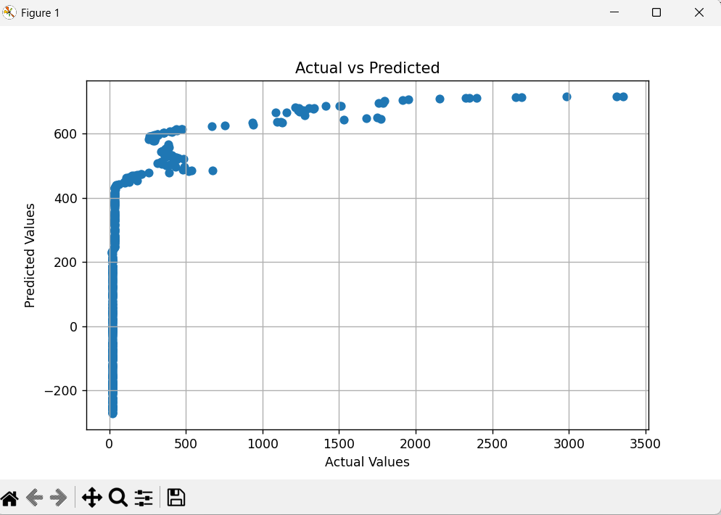

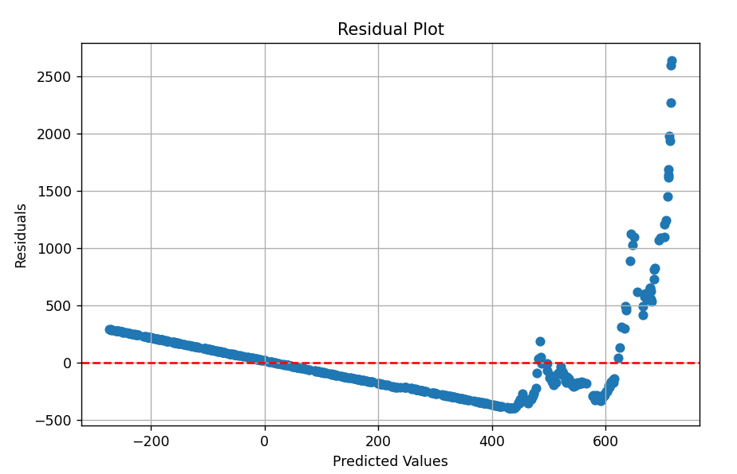

PRO 5
INPUT:

# Import necessary libraries
from sklearn.model_selection import train_test_split
from sklearn.preprocessing import StandardScaler
from sklearn.neighbors import KNeighborsClassifier
from sklearn.metrics import precision_score, recall_score, f1_score, accuracy_score, confusion_matrix
from sklearn.datasets import load_breast_cancer
import pandas as pd
import numpy as np
# -----------------------------
# 1. Load Dataset
# -----------------------------
cancer = load_breast_cancer()
X = cancer.data
y = cancer.target # 0 = malignant, 1 = benign
# -----------------------------
# 2. Train-Test Split
# -----------------------------
X_train, X_test, y_train, y_test = train_test_split(
X, y, test_size=0.2, random_state=42
)
# -----------------------------
# 3. Feature Scaling
# -----------------------------
scaler = StandardScaler()
X_train = scaler.fit_transform(X_train)
X_test = scaler.transform(X_test)
# -----------------------------
# 4. Train kNN Model
# -----------------------------
knn = KNeighborsClassifier(n_neighbors=5)
knn.fit(X_train, y_train)
# -----------------------------
# 5. Model Evaluation
# -----------------------------
y_pred = knn.predict(X_test)
precision = precision_score(y_test, y_pred, average='binary')
recall = recall_score(y_test, y_pred, average='binary')
f1 = f1_score(y_test, y_pred, average='binary')
accuracy = accuracy_score(y_test, y_pred)
print("Precision:", precision)
print("Recall:", recall)
print("F1 Score:", f1)
print("Accuracy:", accuracy)
# -----------------------------
# 6. Confusion Matrix
# -----------------------------
cm = confusion_matrix(y_test, y_pred)
print("Confusion Matrix:\n", cm)

OUTPUT:
Precision: 0.9577464788732394
Recall: 0.9577464788732394
F1 Score: 0.9577464788732394
Accuracy: 0.9473684210526315
Confusion Matrix:
[[40 3]
[ 3 68]]

